

***Software Requirement and Design***

***Specifications***



***NAIKI***

|  |  |  |
| --- | --- | --- |
| Course Code | CS-324 Software Design and Analysis | |
| Instructor | | Miss Syeda Rubab Jaffar | |
| Project Team | | Ovaiz Ali 18K-0137  Zaeem Ahmed 18K-0166  Muhammad Hasan 18K-0294 | |
| Submission Date | | 21 December 2020 | |



Page 2 of 12

*Table of Contents*

*1. INTRODUCTION.....................................................................................................................................................4*

1.1. Purpose of Document.........................................................................................................................4

1.2. Intended Audience ..............................................................................................................................4

*2. OVERALL SYSTEM DESCRIPTION ............................................................................................................................5*

2.1. Project Background.............................................................................................................................5

2.2. Project Scope ......................................................................................................................................5

2.3. Not In Scope ........................................................................................................................................5

2.4. Project Objectives ...............................................................................................................................5

2.5. Stakeholders........................................................................................................................................5

2.6. Operating Environment ......................................................................................................................5

2.7. System Constraints.............................................................................................................................6

2.8. Assumptions & Dependencies ..........................................................................................................6

*3. EXTERNAL INTERFACE REQUIREMENTS..................................................................................................................7*

3.1. Hardware Interfaces ...........................................................................................................................7

3.2. Software Interfaces.............................................................................................................................7

3.3. Communications Interfaces ...............................................................................................................7

*4. FUNCTIONAL REQUIREMENTS................................................................................................................................8*

*4.1. FUNCTIONAL HIERARCHY .............................................................................................................................8*

4.2. Use Cases............................................................................................................................................9

4.2.1. [Title of use case] ...........................................................................................................................9

*5. NON-FUNCTIONAL REQUIREMENTS........................................................................................................................11*

5.1. Performance Requirements...............................................................................................................11

5.2. Safety Requirements ..........................................................................................................................11

5.3. Security Requirements .......................................................................................................................11

5.4. User Documentation...........................................................................................................................11

*SDS .........................................................................................................................................................................12*

***6. SYSTEM ARCHITECTURE ............................................................................................................................13***

*6.1. SYSTEM LEVEL ARCHITECTURE ...................................................................................................................13*

***7. DESIGN STRATEGY .......................................................................................................................................14***

***8. DETAILED SYSTEM DESIGN.......................................................................................................................14***

*8.1. DATABASE DESIGN .....................................................................................................................................15*

*8.2. APPLICATION DESIGN........................................................................................................................................16*

*9. REFERENCES ......................................................................................................................................................22*

*10. APPENDICES......................................................................................................................................................22*

***1. Introduction***

***1.1. Purpose of Document***

To provide automated efficient system for Pakistan which connects privileged with the underprivileged people of Pakistan.

***1.2. Intended Audience***

Donors, Help Seekers, and workers of NGO

**1.3 Definition of Terms, Acronyms and Abbreviations**

***Term Description***

***1.4 Document Convention***

NA

***2. Overall System Description***

***2.1. Project Background***

As per the latest poverty estimates, 24% of Pakistan's population lives below the national poverty line; which includes 31% in rural areas and 13% in urban areas. Hence, there is a desperate need for an automated efficient system for Pakistan which connects privileged with the underprivileged people of Pakistan.

Therefore, NAIKI is a system which takes Donors and the Help seekers on board in order to support those in need.

***2.2. Project Scope***

This project will deliver a platform for people to donate whatever they are fortunate with (blood, money, clothes, time, knowledge), for the betterment of the lower and underprivileged class people who are living hand to mouth conditions or have lost their home due to natural disasters or any reason and for the betterment of the environment of the country. Moreover, it also encourages people to donate more and more as the user will also receive points after each donation depending upon the amount and type of donation made which can later be redeemed for free or discounted items at the selected store. (or these points can be donated again in form of cash).

***2.3. Not In Scope***

NA

***2.4. Project Objectives***

* Donors would be able to donate whatsoever they want to, to a help seeker of their own choice within the domain of our project (Food, Money, Books, Clothes, Free Education, Voluntary Work)
* Help seekers would be able to view the donated items and may select whichever they require or they can just request for the items or amount they need.
* Donors would be given points/badges which can be redeemed from any of the organizations/firms which supports/promotes our work scheme in order to achieve sustainability.

***2.5. Stakeholders***

* Donors
* Help Seekers
* NGO

***2.6. Operating Environment***

Need Simple Computer System with Internet facility to operate this portal.

***2.7. System Constraints***

• *Software constraints:*

Minimum Operating System Requirement: Windows 7

• *Hardware constraints:*

Need computer system

• *Cultural constraints:*

The portal is in English Language

• *User constraints:*The user should be literate enough to use modern tech and can understand English.

***2.8. Assumptions & Dependencies***

NA

***3. External Interface Requirements***

***3.1. Hardware Interfaces***

The system is a web-based application; clients are required using a modern web browser such as Google Chrome, Mozilla Firefox and Enable Cookies. The computer must have an Internet connection in order to be able to access the system.

***3.2. Software Interfaces***

All pages of the system are following a consistent theme and clear structure. The occurrence of errors should be minimized using checkboxes, radio buttons and scroll down in order to reduce the amount of text input from the user. Proper Grids to display information to give a clear structure that is easy to understand by the user. Error messages should be located beside the error input which clearly highlight and tell the user how to solve it. The page should display the project process in different colors.

***3.3. Communications Interfaces***

The HTTP/HTTPS protocol will be used to facilitate communications between the client and server

***4. Functional Requirements***

***4.1. Functional Hierarchy***

***4.2. Use Cases***

***4.2.1. NAIKI***

***Use Case Diagram***

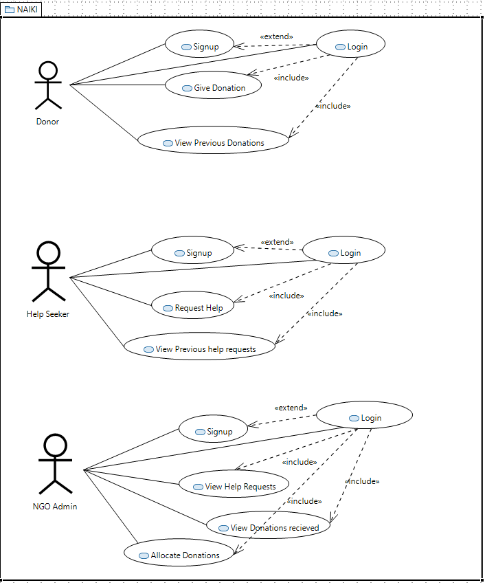

***Use Case Description***

|  |  |
| --- | --- |
| Use Case Name: | NAIKI |
| Use Case Description: | This project will deliver a platform for people to donate whatever they are fortunate with (blood, money, clothes, time, knowledge), for the betterment of the lower and underprivileged class people who are living hand to mouth conditions or have lost their home due to natural disasters or any reason and for the betterment of the environment of the country. |
| Actors: | Help Seeker, NGO, Donor, System |
| Pre-Conditions: | 1. Help Seeker must be needy 2. Donor must have the goods to donate he is posting for 3. The user can be either donor, help seeker or admin at a time |
| Flow of Events: | **If the user is Donor**   1. Signup 2. Login 3. Give Donation (Fill Donation form) 4. View previous Donations   **If the user is Seeker**   1. Signup 2. Login 3. Request for Help (Fill Help Request form) 4. View previous help requests   **If the user is Admin**   1. Signup 2. Login 3. View all Donations not given to any seeker 4. View all Help requests which are not fulfilled 5. Allocate Donation |
| Post Conditions | 1. Donor donated the goods when the request is matched 2. Help seeker received the donation he was in need. |

***5. Non-functional Requirements***

***5.1. Performance Requirements***

The system must be interactive, and the delays involved must be less. So, in every action-response of the system, there are no immediate delays

***5.2. Safety Requirements***

Information transmission should be securely transmitted to the server without any changes in information.

***5.3. Security Requirements***

The main security concern is for users' accounts hence proper login mechanism should be used to avoid hacking. Hence, security is provided from unwanted use of recognition software.

***5.4. User Documentation***

As the system provides the right tools for discussion, problem solving must be made sure that the system is reliable in its operations and for securing the sensitive details.

***SDS***

***6. System Architecture***

**6.1. System Level Architecture**

***Component Diagram***

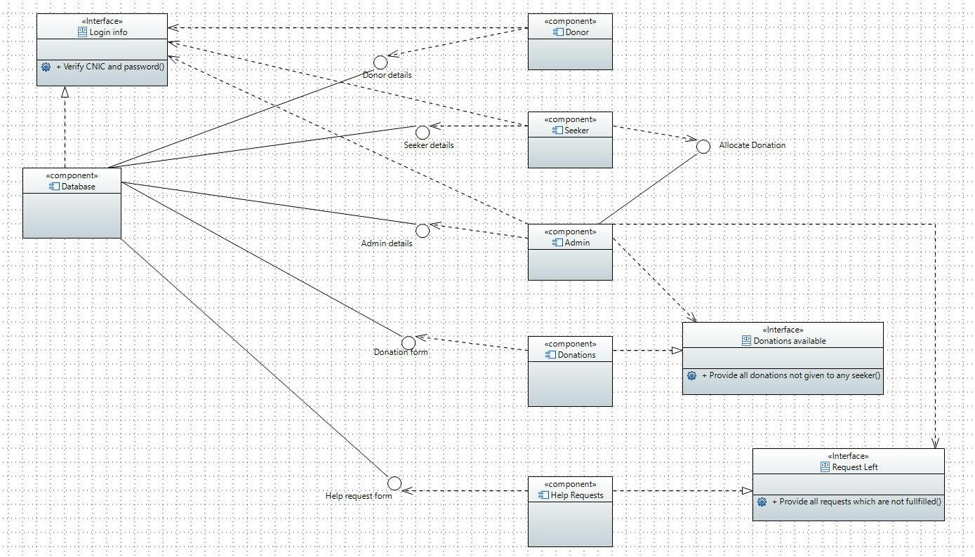

***Deployment Diagram***

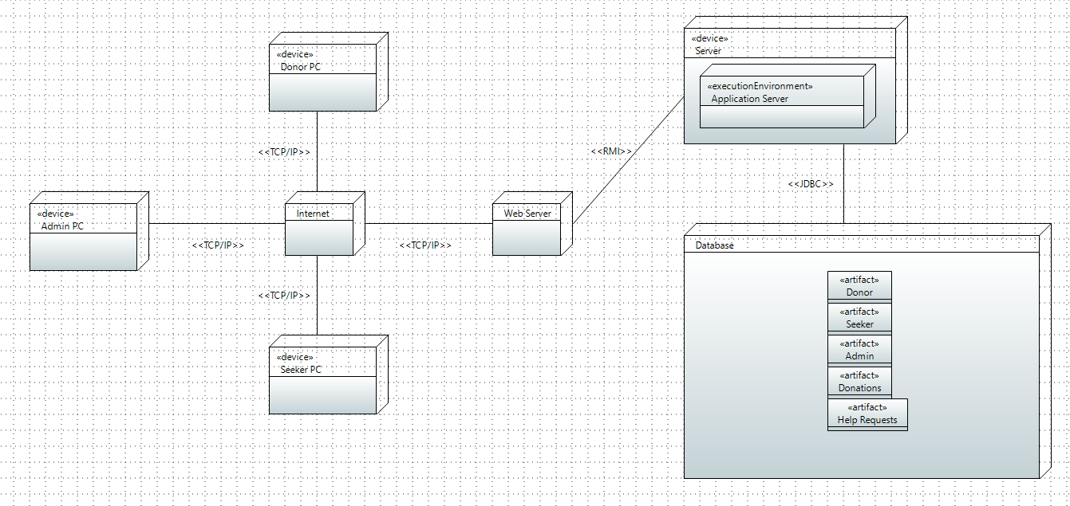

***7. Design Strategy***

We identify the existing problems and ongoing challenges of poverty in our country. So, we successfully build this system which can be used again in the future era. This system is beneficial for the economical crises in Pakistan. The system has a great data management as it stores all the information about donors, help seekers, donations and help requests.

***8. Detailed System Design***

***Class Diagram***

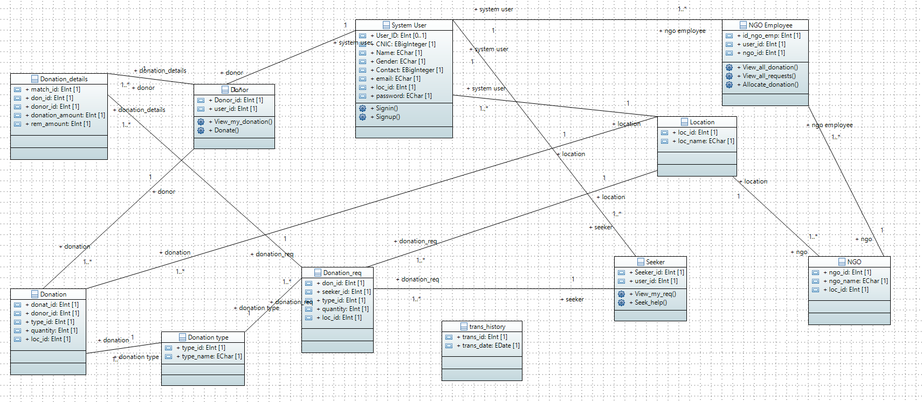

**8.1. Database Design**

***EER Diagram***

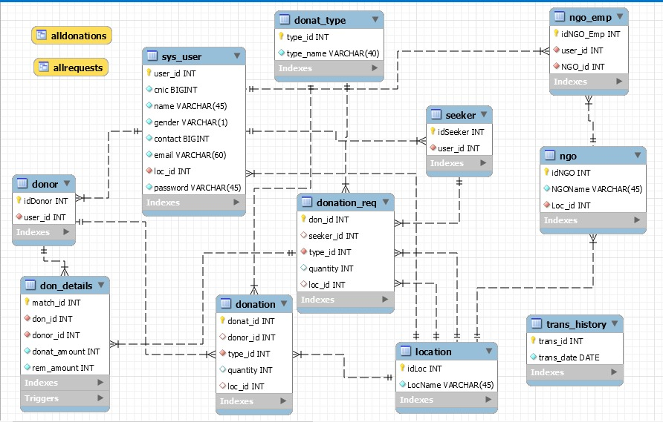

**8.2. Application Design**

***8.2.1 Sequence Diagrams for each use case***

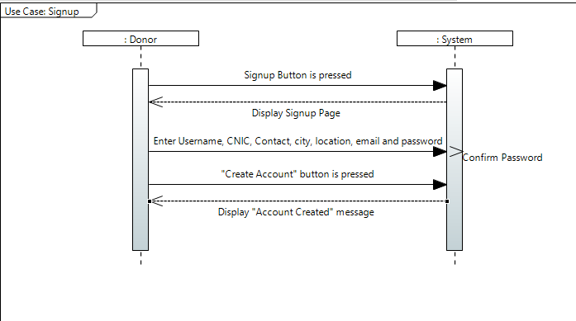

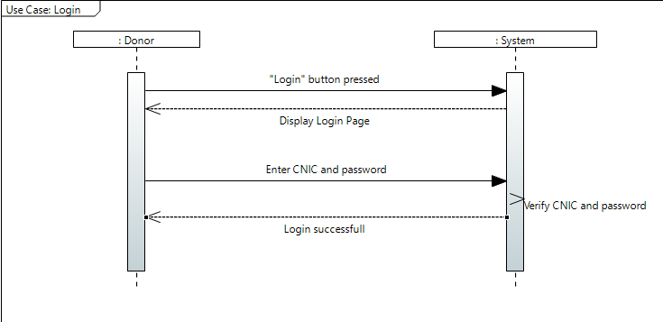

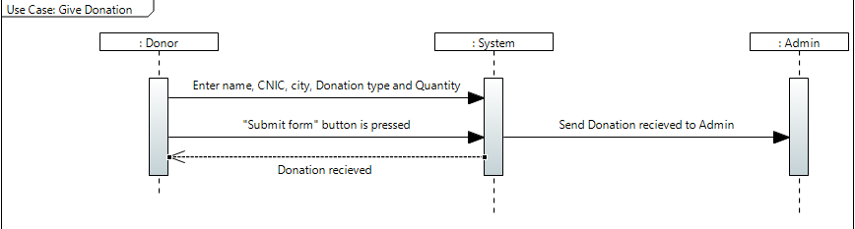

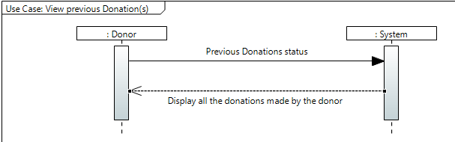

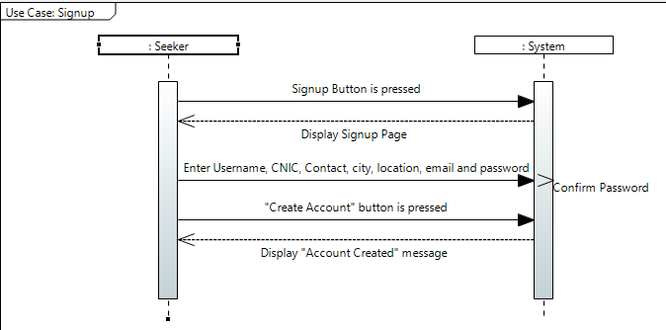

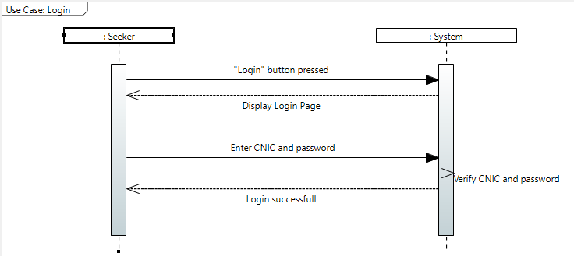

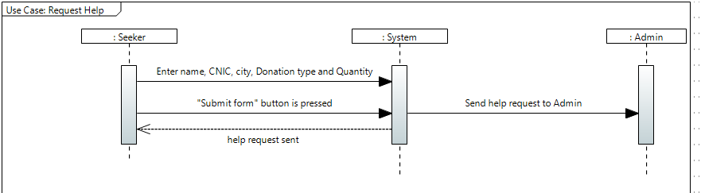

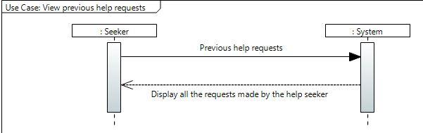

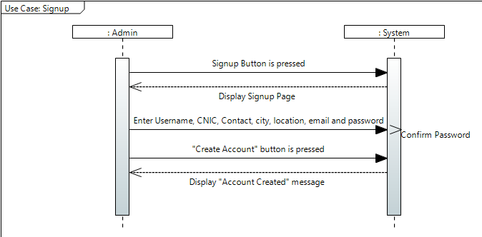

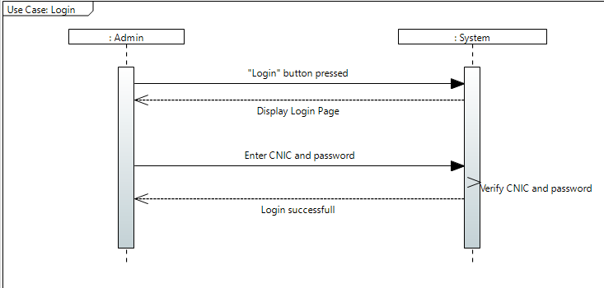

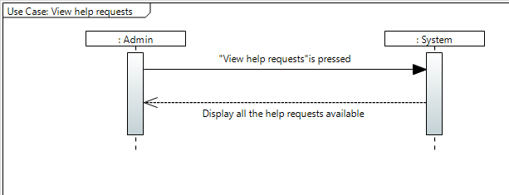

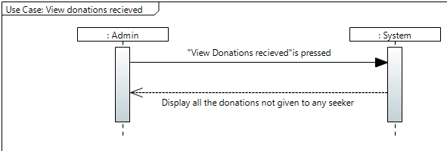

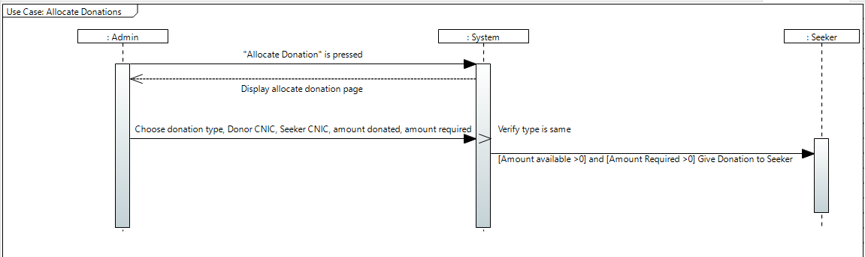

***8.2.2. Collaboration Diagrams for each user***

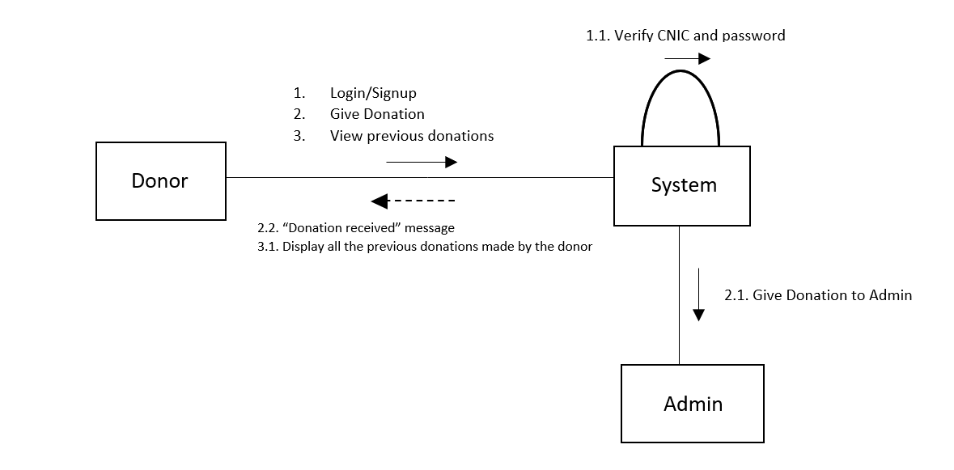

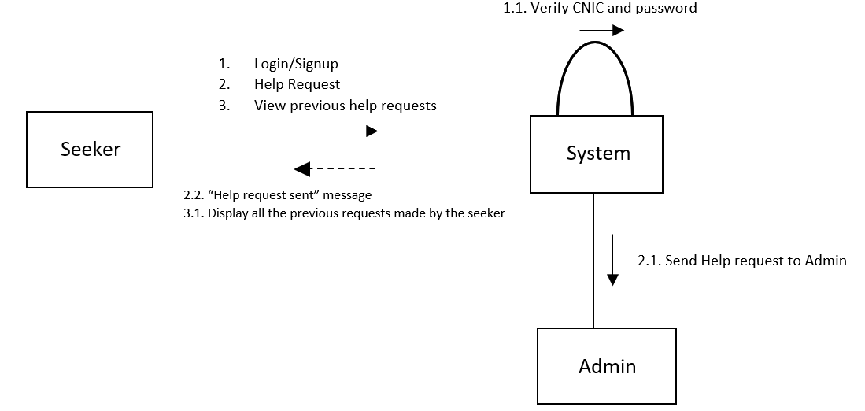

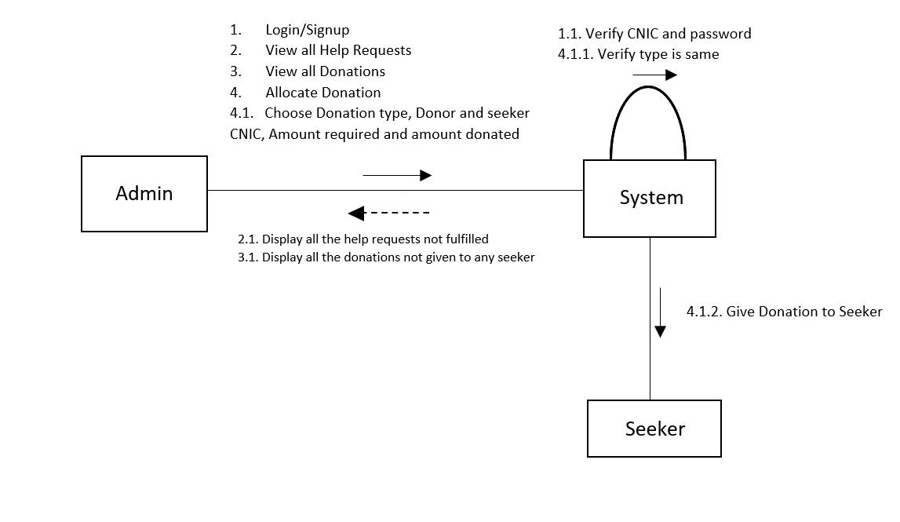

***8.2.3 Activity Diagram***

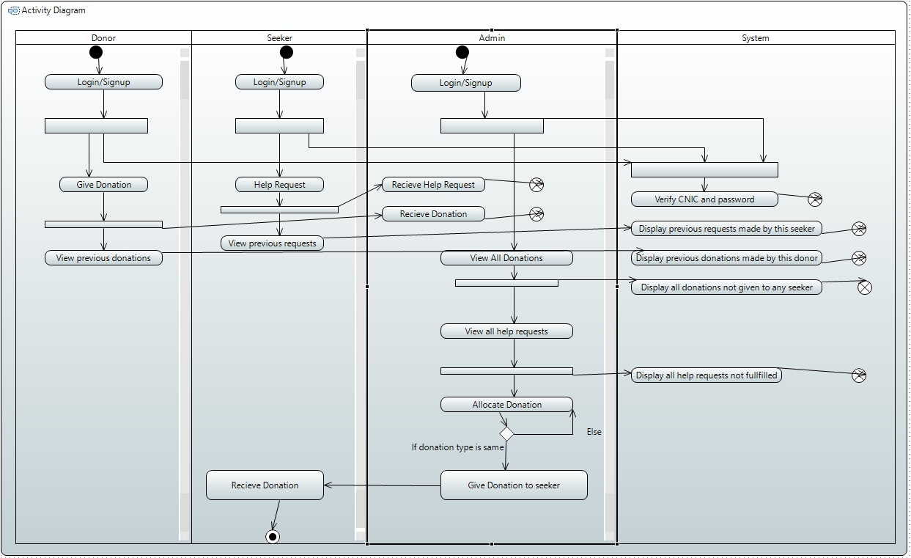

***9. References***

Miss Lectures

***10. Appendices***

NA